1st step Registration form

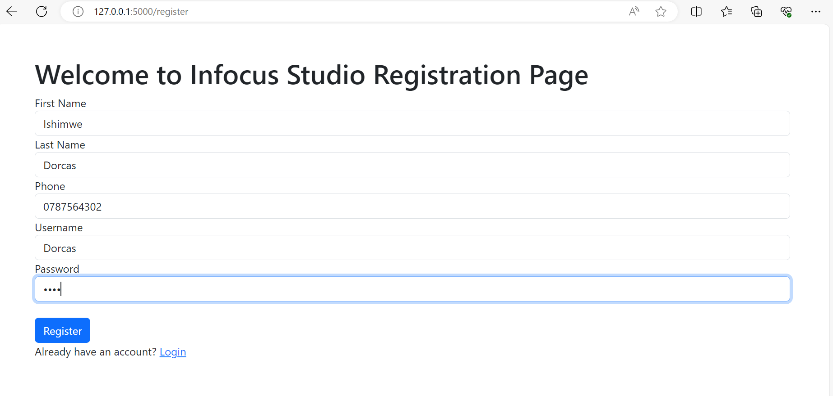

2nd **step**  Login form

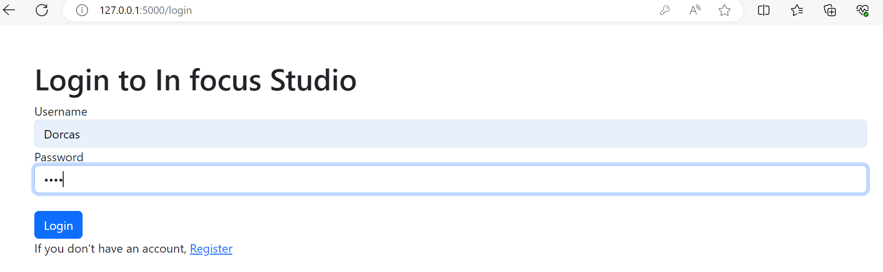

3rd step orderform

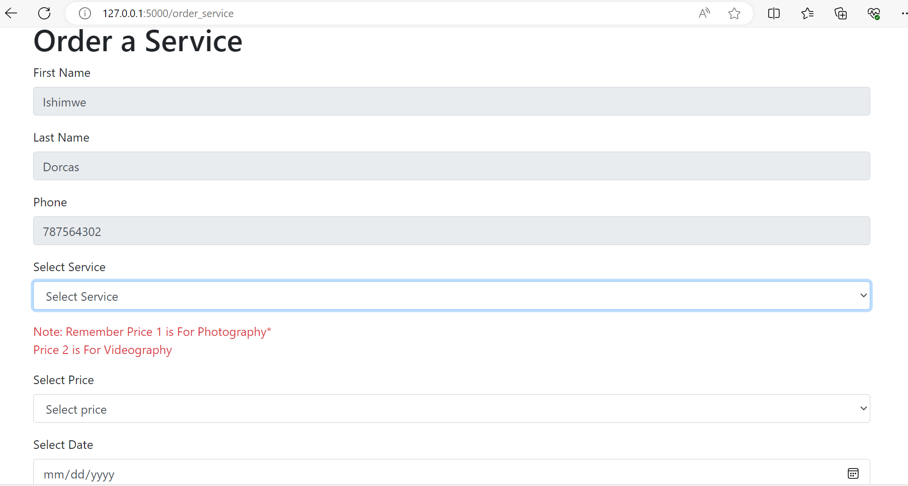

4th  step Dashboard

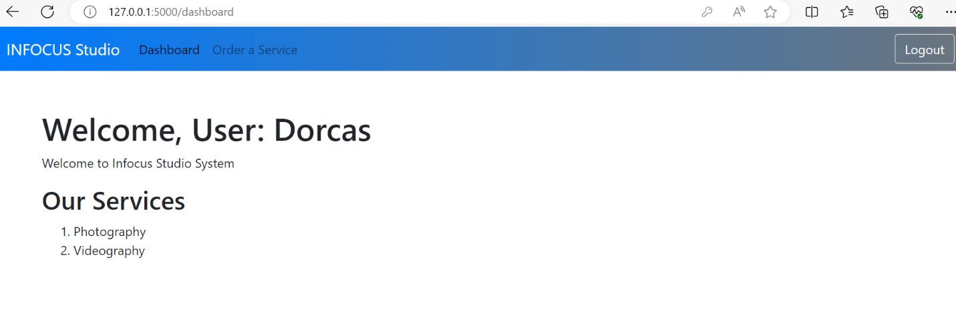

5th step ordered successfully

